Payroll Software Documentation

MASTER MENU

- Login Form
This Login Form accepts UserName, Password, and name of Company to which User wants to Login. Users have to input all these parameters to get access for the application.

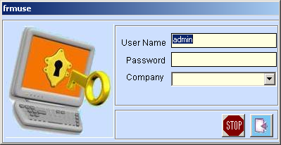
Fig. 1: Login Form

- Main Form
This is the main form which gives user access to multiple actions to be performed. Here user can select any form or report to view details, of which user has given authorization.

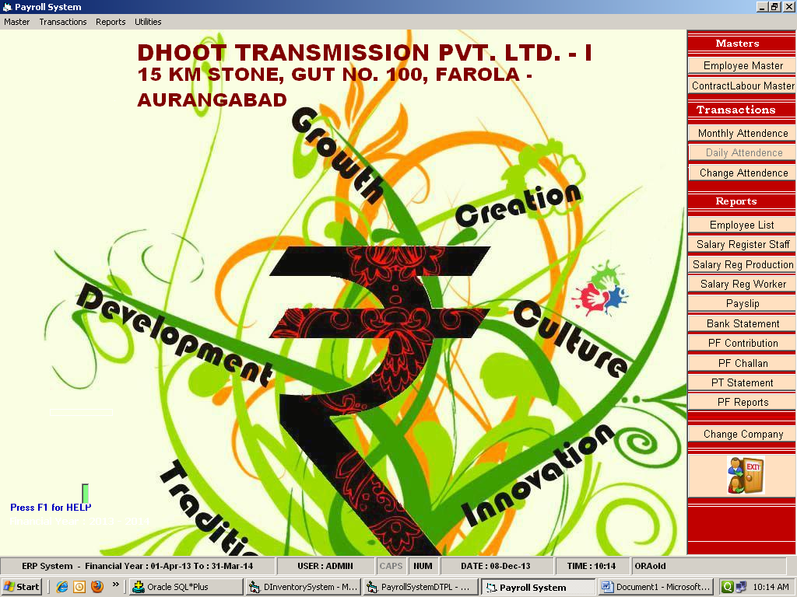
Fig. 2: Main MDI Form

- DEPARTMENT MASTER FORM
- List Form:
This form displays the list of departments available into the system.

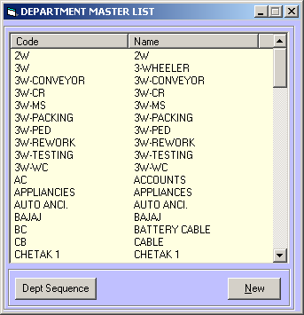
Fig. 3: Department Master Form

- Entry Form:
Following entry form allows user to enter/ modify the details regarding any Department. Name of Dept. and its description must not be greater than 30 characters.

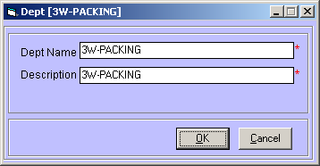
Fig. 4: Department Master Entry Form

- DESIGNATION MASTER FORM
- List Form:
This form displays the list of Designations available into the system. This form also enables User to choose action to be performed by clicking right button of Mouse.

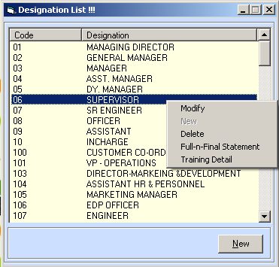

Fig. 5: Designation Master Form
- Entry Form:
Following entry Form allows user to enter new Designation details or modify the details of existing Designation. Designation field must not contain more than 15 characters. And Description Column must not contain more than 30 characters.

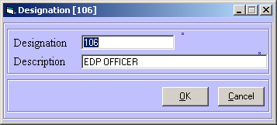
Fig. 6: Designation Master Entry Form

- BANK MASTER FORM

- List Form:
This form displays the list of Banks associated with the Company. This form also enables user to choose action to be performed by clicking right button of Mouse.

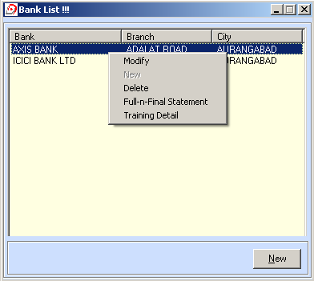
Fig. 7: Bank Master List Form

- Entry Form:
Following Form enables User to enter new Bank Details or modify that of existing one.
Bank Name must not be greater than 30 characters. Branch Name must not be greater than 35 characters. City must not be greater than 30 characters.

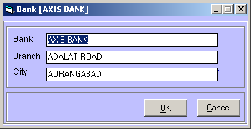
Fig. 8: Bank Master Entry Form

- LEAVE TYPE MASTER
- List Form:
This form displays the list of Types of leaves available in the organization. This form provides the user, the list of operations which can be performed on the selected item.

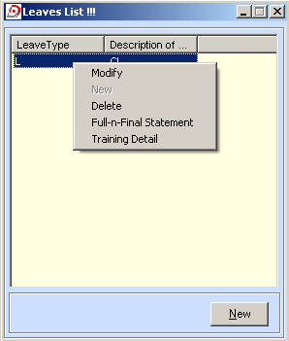
Fig. 9: Leave Type Master

- Entry Form:
This form allows user to enter new Leave type or modify the existing one.
“Leave Type Code” is the abbreviation used commonly for Leave.
“Description” is the complete name for Leave Type.
“Leave Type Code” must not be greater than 3 characters and “Description” must not be greater than 15 characters.

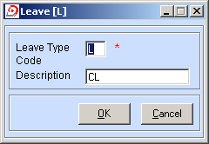
Fig. 10: Leave Type Entry Form

- SHIFT MASTER
- List Form:
This form displays the list of Shifts available into the organization. This form allows user to perform operations like Modify, Delete or Enter New Shift.

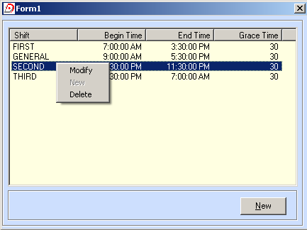
Fig. 11: Shift Master List Form

- Entry Form:
fgdg

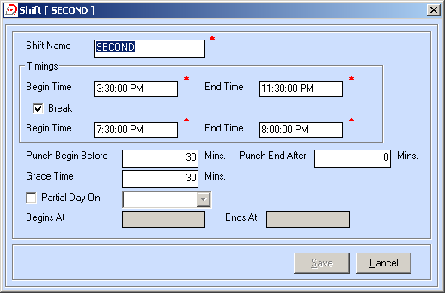
Fig. 12: Shift Master Entry Form

- PT SLAB MASTER
- List Form:

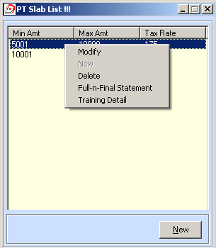
Fig. PT Slab Master List Form
- Entry Form:

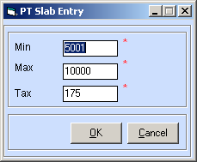
Fig. PT Slab Master Entry Form

- HOLIDAY MASTER
- List Form:

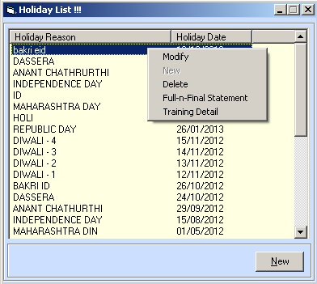
Fig. Holiday Master List Form

- Entry Form:

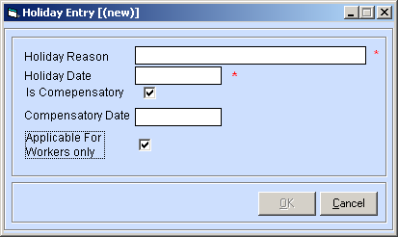
Fig. Holiday Master Entry Form

- CONTRACTOR MASTER
- List Form:

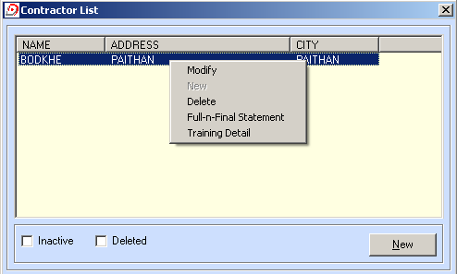
Fig. Contractor Master List Form

- Entry Form:

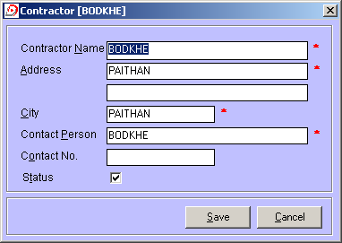
Fig. Contractor Master Entry Form

- EMPLOYEE TYPE MASTER
- List Form:

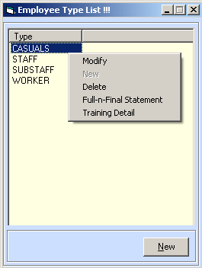
Fig. Emp. Type Master List Form

- Entry Form:
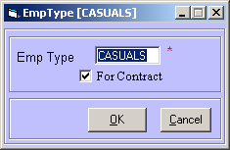
Fig. Emp Type Master Entry Form

- EMPLOYEE STATUS MASTER
- List Form:

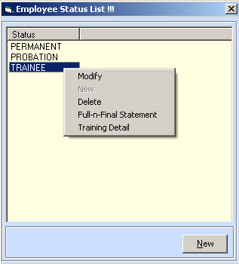
Fig. Emp. Status List Form

- Entry Form:

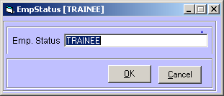
Fig. Emp Status Entry Form

- EMPLOYEE MASTER
- List Form:

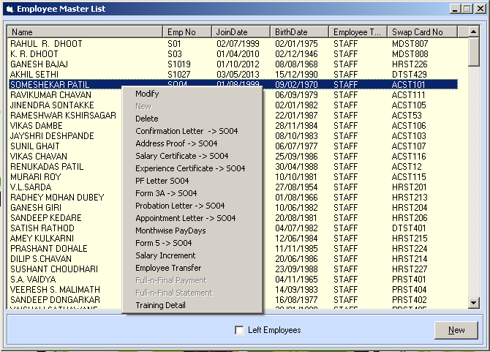
Fig. Employee Master List Form

b) Entry Form:

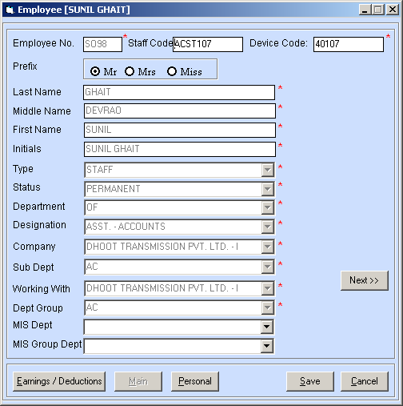
Fig. (a): Employee Master Entry Form – Screen 1

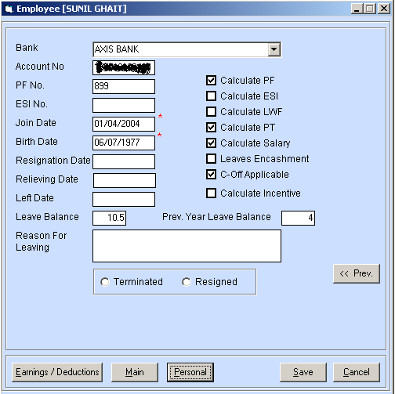
Fig. (b): Employee Master Entry Form – Screen 2

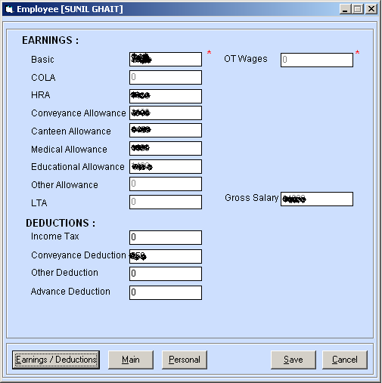
Fig. (c): Employee Master Entry Form – Screen 3

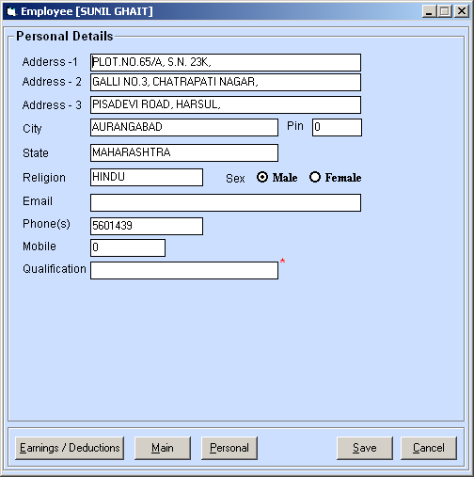
Fig. (d): Employee Master Entry Form – Screen 4

- CONTRACT LABOUR MASTER
- List Form:

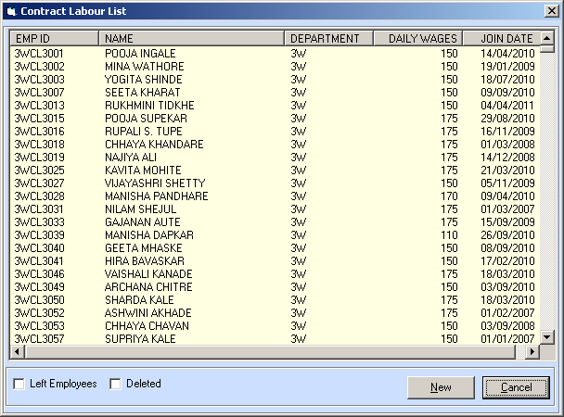
Fig. Contract Labour Master List Form

- Entry Form:

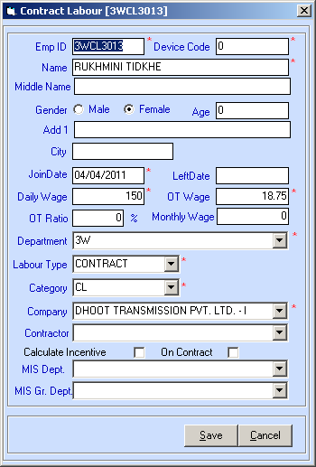
Fig. Contract Labour Master Entry Form

- LABOUR MASTER
- List Form:

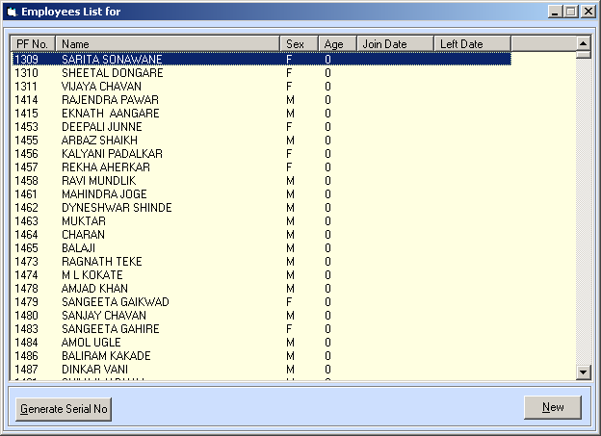
Fig. Labor Master List Form

- Entry Form:

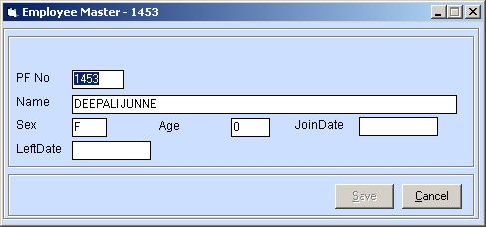
Fig. Labour Master Entry Form

- Daily Attendance:

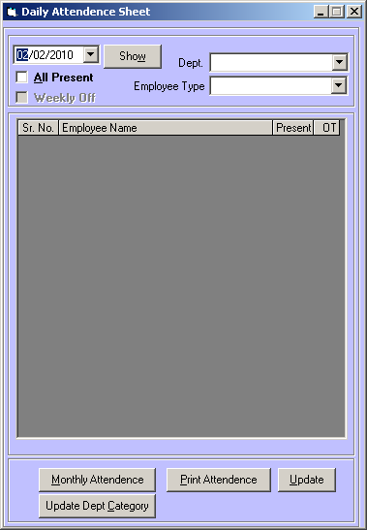
Fig. Daily Attendance Entry Form

- Contract Labour Muster Monthly Attendance:
- List Form:

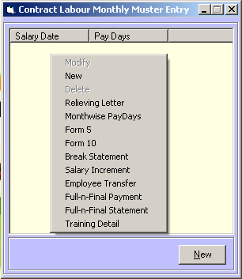
Fig. Contract Labour Muster Monthly List Form

- Entry Form:

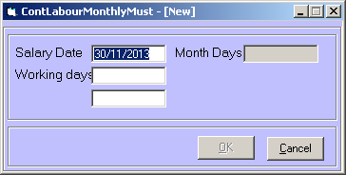
Fig. Contract Labour Entry Form

- CASUAL WAGES FORM
- List Form:

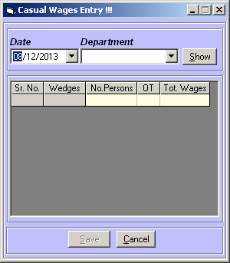
Fig. Casual Wages Entry Form

- WAGE MASTER
- List Form:

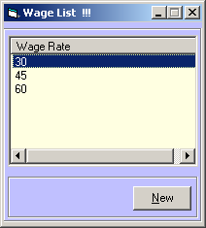
Fig. Wages Master List Form

- Entry Form:
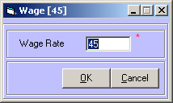
Fig. Wags Master Entry Form

- TOPIC CATEGORY MASTER
- List Form:

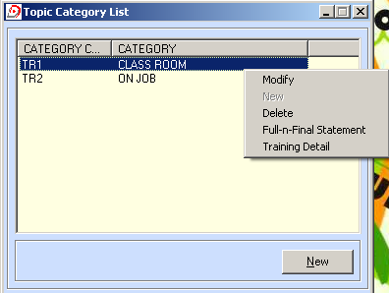
Fig. Topic Category Master List Form

- Entry Form:
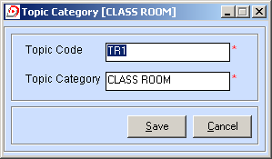
Fig. Topic Category Entry Form

- TOPIC MASTER
- List Form:

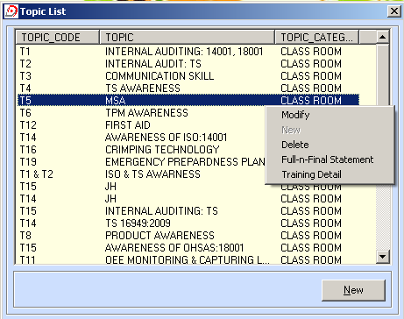
Fig. Topic Master List Form.

- Entry Form:

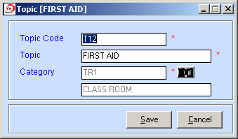
Fig. Topic Master Entry Form

- FACULTY MASTER
- List Form:

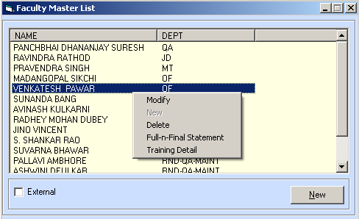
Fig. Faculty Master List Form

- Entry Form:

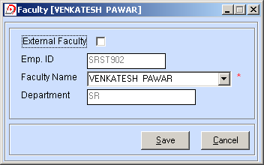
Fig. (a): Faculty Master Entry Form (Internal Faculty)

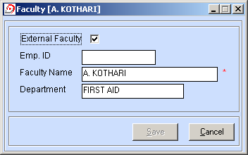
Fig. (b): faculty Master Entry Form (External Faculty)
TRANSACTION MENU

- ATTENDANCE – DAILY

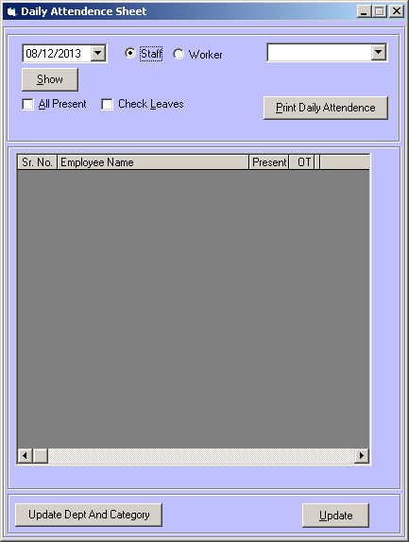
Fig. Daily Attendance Entry Form

- SALARY LOCK
- List Form:

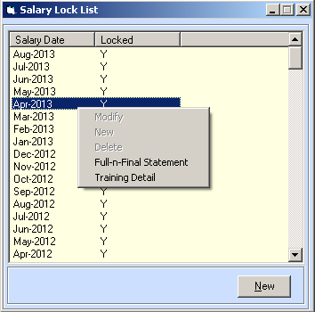
Fig. Salary Lock List Form

- Entry Form:

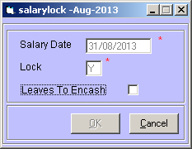
Fig. Salary Lock Entry Form

- MUSTER MONTHLY FORM

- List Form:

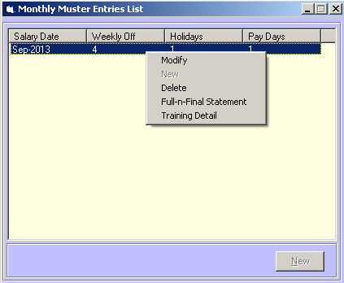
Fig. Muster Monthly List Form

- Entry Form:

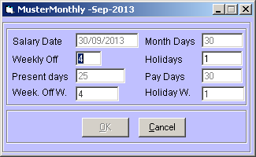
Fig. Muster Monthly Entry Form

- EMP. WISE SALARY DEDUCTION ENTRY

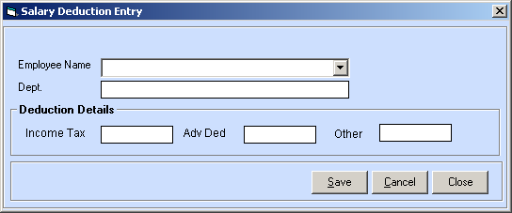
Fig. Emp-Wise Salary Deduction Entry

- PF ENTRY FOR LABOURS
- List Form:

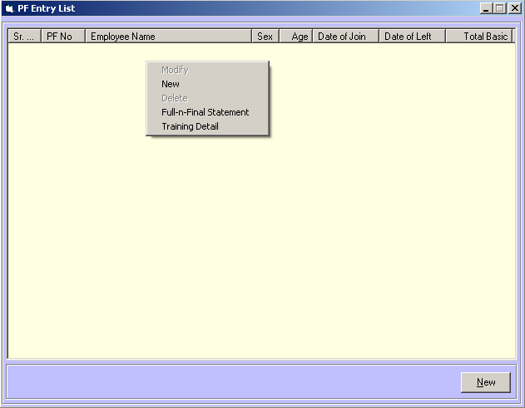
Fig. Labour PF entry List Form

- Entry Form:

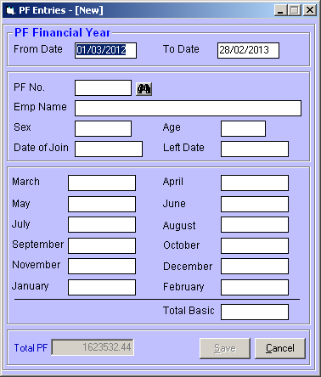
Fig. Labour PF Entry Form

- Form 16 Processing
  - Entry Form:
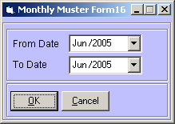
Fig. Form 16 Processing Form

- Form 16 Entry
  - Entry Form:
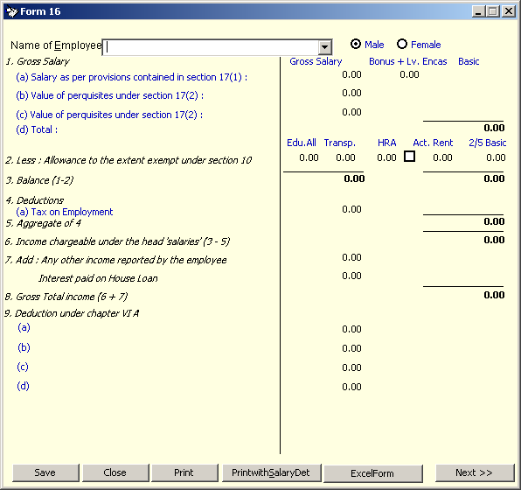
Fig. Form 16 Entry Form

- Leave Status Form
  - List Form:

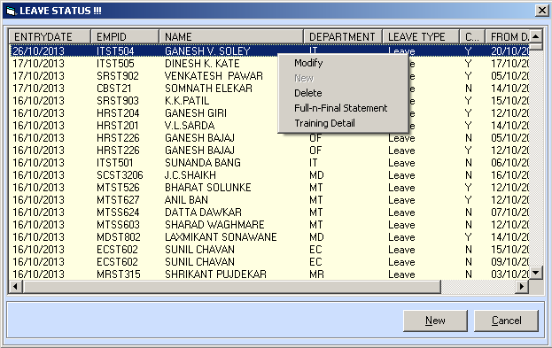
Fig. Leave Status List Form

  - Entry Form:

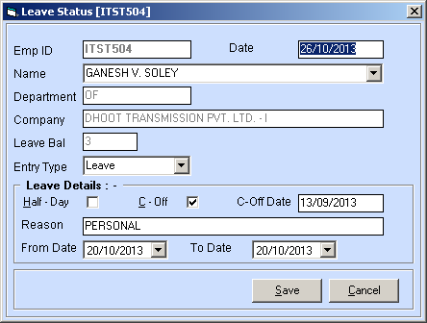
Fig. Leave Status Entry Form

- OnJob Training Form
  - List Form:
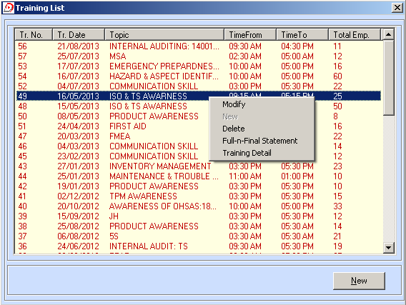
Fig. Training List Form

  - Entry Form:

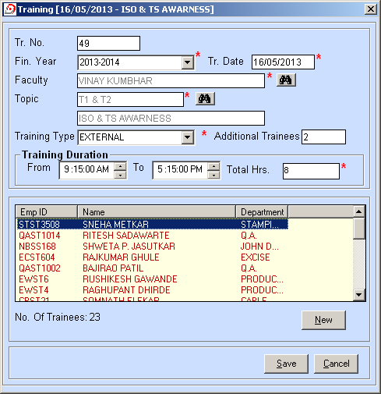
Fig. OnJob Training Entry Form

- Incentive Scheme Form
  - List Form:

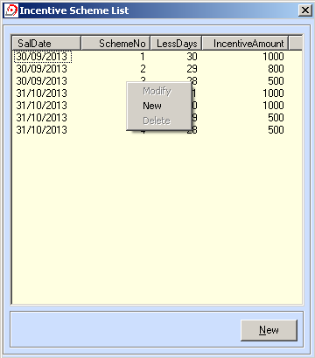
Fig. Incentive Scheme List Form

  - Entry Form:

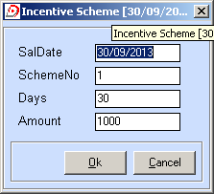
Fig. Incentive Scheme Entry Form

- Incentive Details Form
  - List Form:

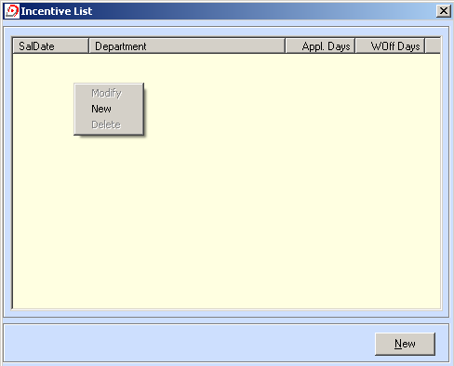
Fig. Incentive Detail List Form

  - Entry Form:

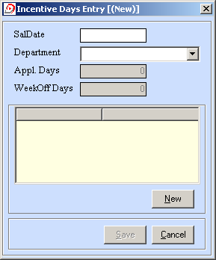
Fig. Incentive Detail Entry Form

REPORTS MENU

- CALCULATE ATTENDANCE FORM
  - Parameter Input Form:

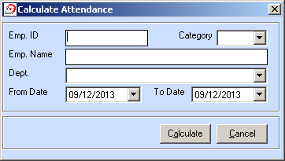
Fig. Calculate Attendance Parameter Entry Form

- DOS BASED REPORTS
  - Report List Form:

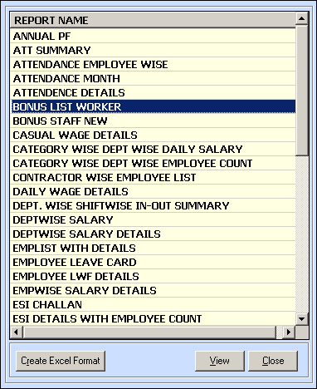
Fig. Report List Form

  - Report Parameter Input Form:

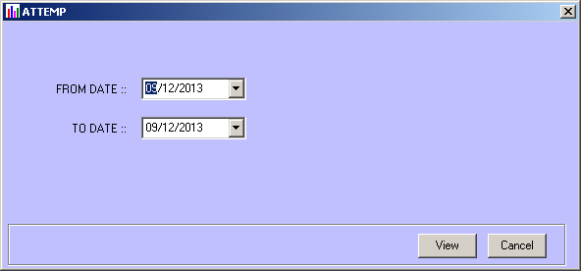
Fig. Report Parameter Input Form

- PF REPORTS
  - PF Contribution Employee List:
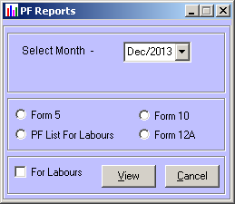
Fig. PF contribution Employee List Parameter form

  - PF Contribution for Labours

Fig. PF contribution for Labor Parameter form

  - Yearly PF Details

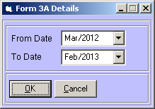
Fig. Yearly PF Detail Parameter Form (Form 3A)

- GENERAL REPORTS
    - Monthly General Reports:
- Salary Register For Staff
- Salary Register For Workers
- PaySlip
- Bank Statement
- PF & FPF Contribution
- PF & FPF Challan
- PT Statement
- Emp. List with Net Salary
- Leaves Encashment

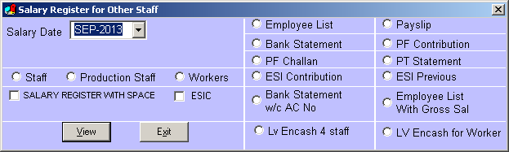
Fig. Monthly Reports Parameter Form

- Form 5
- Form 10
- Form 12

Fig. PF contribution for Labor Parameter form

- PF Process

  - Annual PF Process:

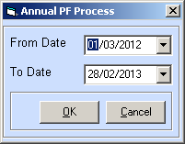
Fig. Annual PF Process Parameter Form

  - PF Process for Labors:

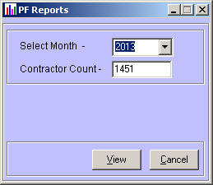
Fig. Labor PF Process Parameter Form

  - PF Process for Staff:

Fig. Labor PF Process Parameter Form
UTILITIES MENU

- User Administration
  - List Form:

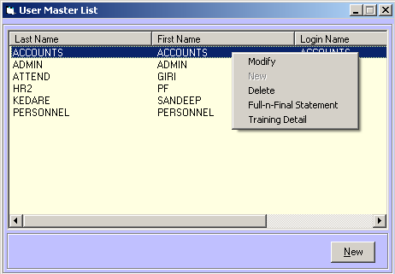
Fig. User Master List Form

  - Entry Form:

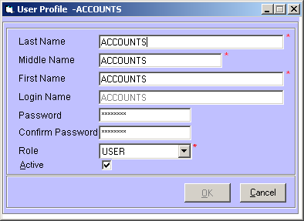
Fig. User Master Entry Form

- User Authentication

  - List Form:
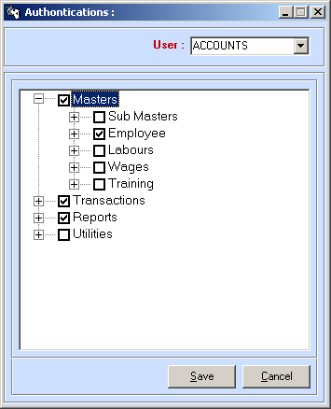
Fig. User Authentication Form

- System Parameters

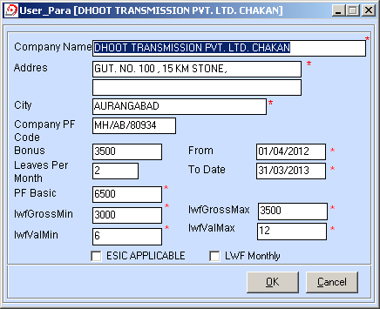
Fig. System Parameters Entry Form

- Backup
- Change Company
  - List Form:

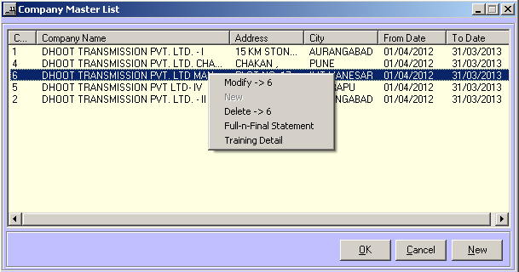
Fig. Company Master List Form

  - Entry Form:
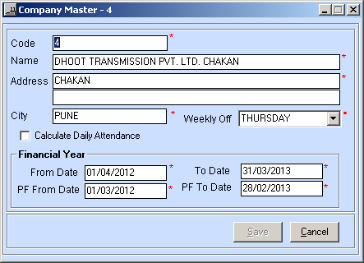
Fig. Company Master Entry Form

- Attendance Import

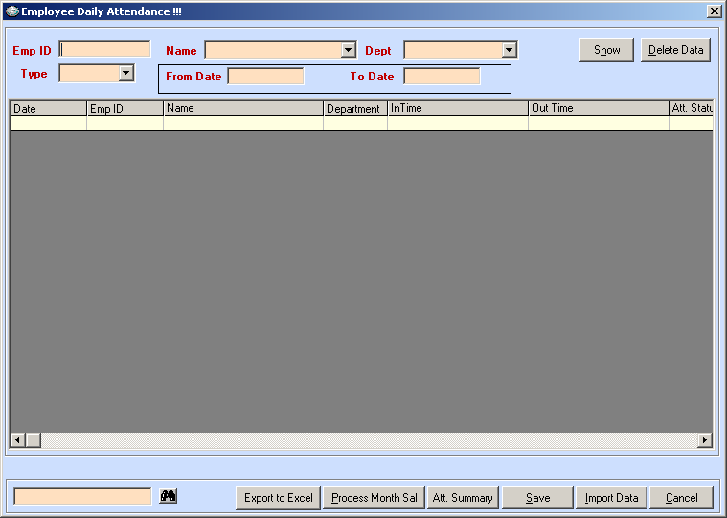
Fig. Attendance Import Form

- Attendance Export

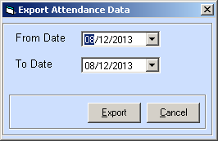
Fig. Export Attendance Parameter Form

